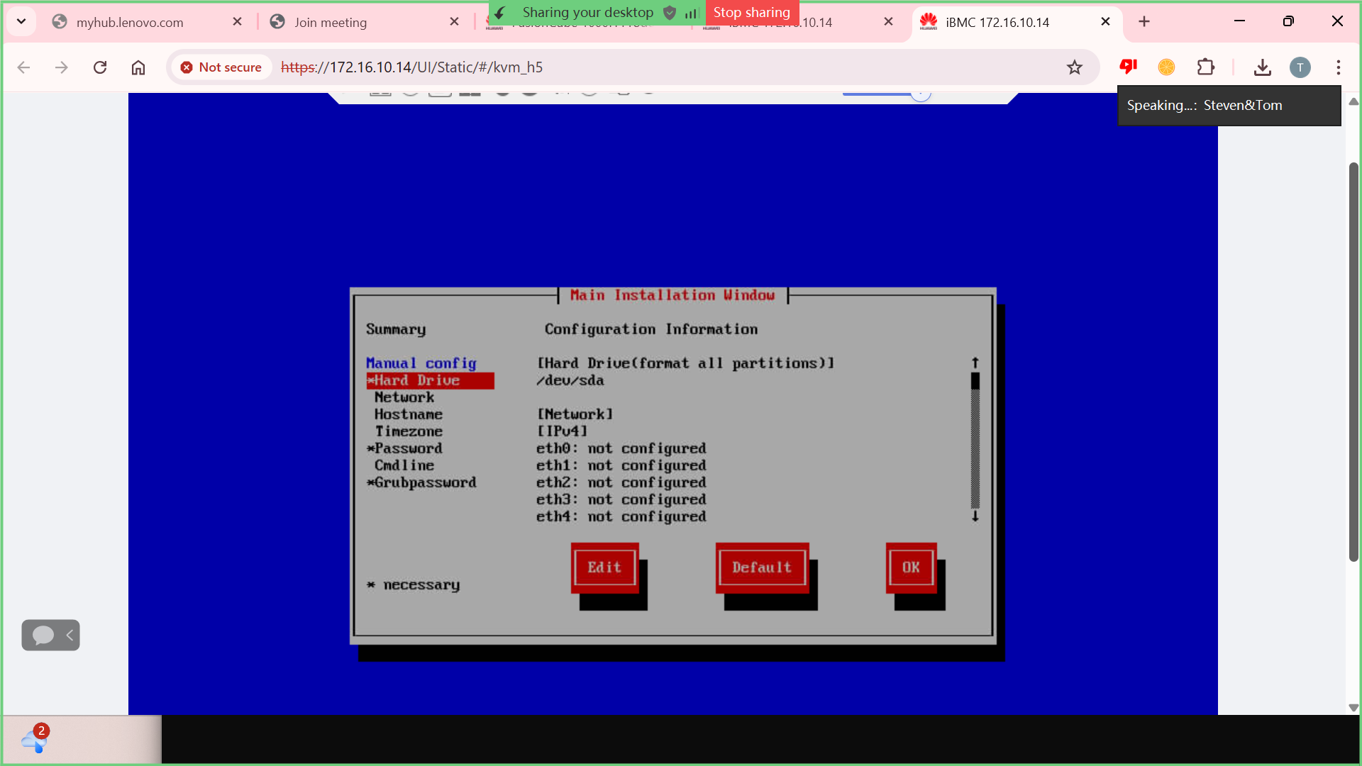

URL: http://172.16.10.14

username: Administrator
Password: Admin@9000

URL: http://172.16.10.25:8443
username: admin
Password: Admin@9000Admin@9000

